**MICROSTRIP PERIODIC STRUCTURES AND THEIR APPLICATION FOR MICROWAVE BANDSTOP FILTER**

**Author:** *Mihajlo Ninkov, fourth grade student, "Jovan Jovanović Zmaj" High school, Novi Sad*

**Mentors:** *Nikolina Janković, Institute „Biosense“, University of Novi Sad* *Milesa Srećković, professor, Faculty of Electrical Engineering , Belgrade*

Regional Center for Young Talents Belgrade II , Serbia, mih.nin05@gmail.com

1. **Introduction**

In analogy to crystal structures, periodic structures are characterized by the existence of a band gap whose properties depend on the geometric parameters of the unit cells composing the periodic structure. Consequently, in recent decades, periodic structures have garnered significant attention in science and engineering, serving as inspiration for numerous applications. This study analyzes microwave periodic structures and their application in a microwave bandpass filter [1].

1. **Material and Work Methods**

The analyzed microwave periodic structure consists of unit cells of length p, composed of two microstrip segments with different widths (Figure 1). Utilizing theoretical concepts such as ABCD matrices and the quasi-static representation of microstrips, mathematical simulations were conducted in the "Octave" program to obtain *k-β* diagrams for various values of geometric parameters *w*, *ws*, and *p*. The diagrams indicate the spectral position and width of the band gap, and an example shown in Figure 2(a) demonstrates that changing the length of the unit cell period leads to a decrease in the central frequency and the width of the band gap. Similar behavior is observed with changes in parameters *w* and *ws*. Considering the limitations of simple theoretical concepts, k-β diagrams were further analyzed using the "CST Studio" software, which is used for numerical analysis of microwave circuits, taking into account effects excluded from theoretical analysis [1,2].

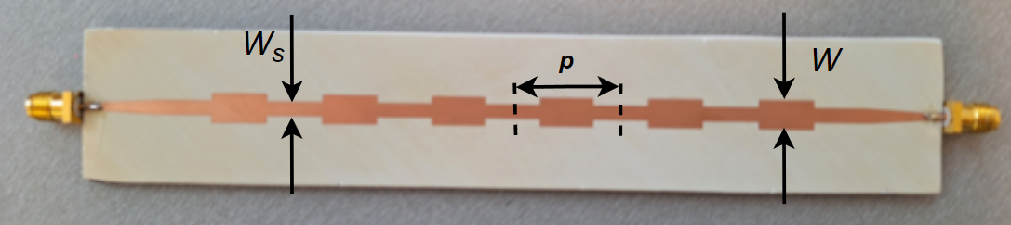

Figure 1: Filtar with dimensions of periodic structures

1. **Results and Discussion**

For a unit cell with parameters *w* = 6 mm, *ws* = 3 mm, and *p* = 22 mm, yielding a band gap with a central frequency of 2.4 GHz and a width of 1.3 GHz, a microwave bandpass filter was designed based on such a unit cell (Figure 2). The filter comprises 6 unit cells and is implemented on a substrate of Rogers TMM10 with a thickness of 1.27 mm and parameters *εr* = 9.8 and *tanδ* = 0.0022. The copper thickness is 0.017 mm. The introductory lines have a width of 1.1 mm to achieve a characteristic impedance of 50 Ω, and they trapezoidally widen to adapt to the filter. The overall dimensions of the filter are 172 x 6 mm2.

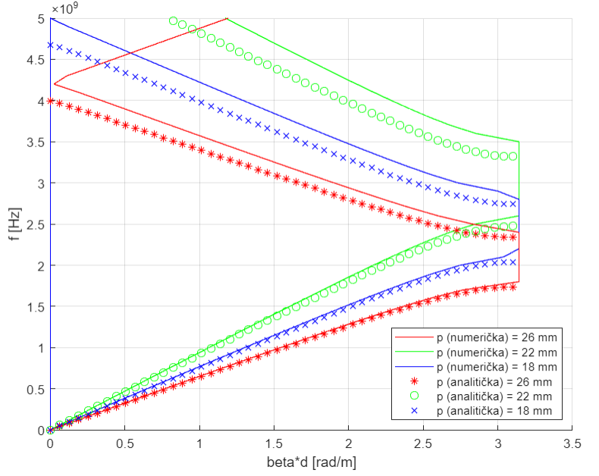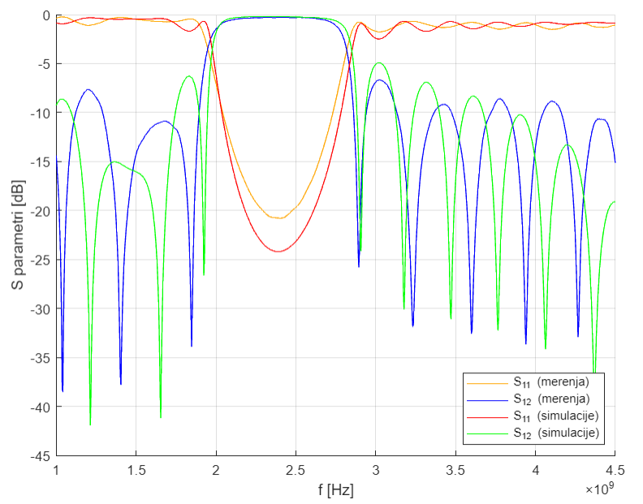  
 *a) b)*

Figure 2: a) k-β diagram for different values of the periodic cell length. b) Display of simulated and measured values of the S parameter

The S-parameters obtained through numerical simulations indicate that the central frequency of the bandpass filter is 2.4 GHz, with a width of 0.7 GHz. The introduced losses at the central frequency are 24.18 dB, satisfying the targeted range. Results obtained from measuring the response of the fabricated circuit on a vector network analyzer demonstrate excellent agreement with the numerical simulation results.

1. **Conclusion**

The conclusion of this study is that periodic structures in microwave circuits behave analogously to crystal structures in terms of the existence of a band gap and its dependence on the geometric parameters of the unit cell. The results have demonstrated that periodic structures are excellent candidates for applications in microwave filters. The analyses in this study will serve as an introduction to further exploration of periodic structures, such as phononic and photonic crystals, metamaterials, and for learning about microwave passive circuits, including antennas.

**5. Literature**

[1] T. Itoh, Periodic Structures for Microwave Engineering

[2] D. M. Pozar, Microwave engineering. John Wiley & sons, 2011.